CHALLENGE#1 Report

Advance Software Engineering

CS551 (SG: 15)

Title: Mobile Grocery Shopping

Submitted By; Medha Dubbaka(Class ID: 13); Sindhuja Sura(Class ID: 36)

1. **Design**

For most businesses, getting new customers is just as important as keeping old ones. If we can assist grocery shops in providing more information to their potential customers, it would most likely encourage new customers to visit them. Our application enables customers to make the list of items they wish to purchase and pay online.

Similar to Google Maps, this application would encourage users to utilize our system as long as their phones have internet data services. With our mobile grocery application, users are able to type names of grocery items and search for it in the specified shop. Our grocery application, by listing all items in the menu, allows users to know how much they need to pay before they make decisions on whether they want to buy that product or not.

This is mostly helpful to the elderly citizens of society who cannot always walk into a grocery shop to make a purchase.

1. **Architecture Diagram:**

This architecture diagram depicts the flow with which the service of the customer is being structured. Initially the customer gets an index page where he can select the category he is interested in. Then he is directed to the category page wherein he can select and add products to his cart. Once he is done with the selection he is directed to cart page where he can see all the items he has selected so far. Finally, the customer is supposed to make payment by giving his personal card details and submit the purchase.

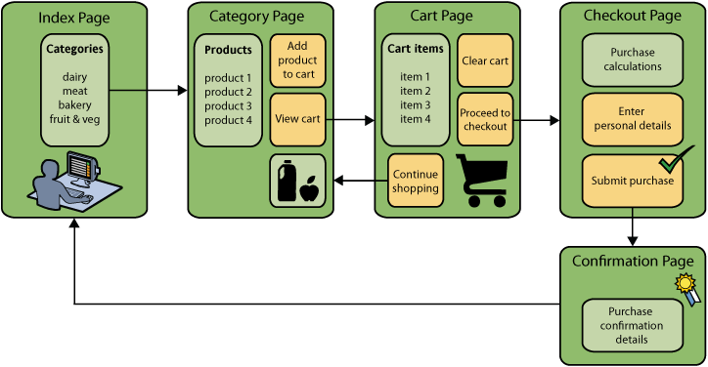

**Fig: 1**

1. **Class Diagram:**

Class diagrams identify the class structure of a system, including the properties and methods of each class. Also depicted are the various relationships that can exist between classes, such as an inheritance relationship.

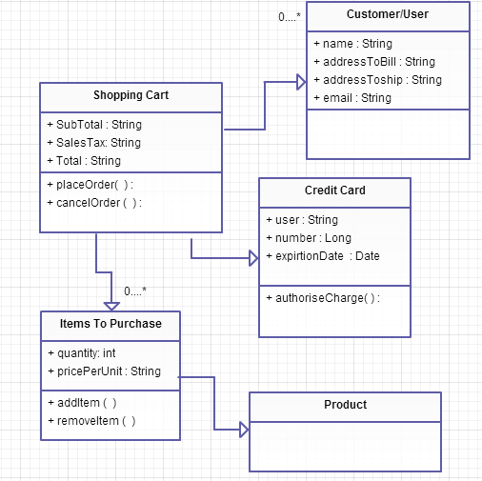

**Fig: 2**

**2) Features Implemented**

**a. Web Services**

We have not implemented any web services but we have gone through the REST Web Services.

**b. Database**

**i. Our own Data Model:**

**Data Elements of User (New User):**

|  |  |  |  |
| --- | --- | --- | --- |
| **Label** | **Data Element Type** | **Validation** | **Description** |
| User_id |  |  | System generated userId |
| First_name | Text box | Mandatory | Provides first name of user |
| Middle_name | Text box | Optional | Provides middle name of user |
| Last_name | Text box | Mandatory | Provides last name of user |
| Address_line1 | Text box | Mandatory | Provides first address line of user |
| Address_line2 | Text box | Optional | Provides second address line of user |
| City | Text box | Mandatory | Provides city of user |
| State | Drop down | Mandatory | Provides state of user |
| Zip | Text box | Mandatory | Provides zip of user |
| Email | Text box | Mandatory | Provides email of user |
| Name_on_card | Text box | Optional | Provides user name on card |
| Cc_num | Text box | Optional | Provides user cc number on card |
| Ccv | Text box | Optional | Provides ccv number of user’s card |
| Expiry_date | Drop down | Optional | Provides expiry date of user’s card |
| User_name | Text box | Mandatory | Provides username of the user |
| Password | Text box | Mandatory | Provides password of the user |
| Security_question | Drop down | Mandatory | Provides security question of the user |
| Security_answer | Text box | Mandatory | Provides security answer of the user |
|  |  |  |  |

**Data Elements of Add Recipe:**

|  |  |  |  |
| --- | --- | --- | --- |
| **Label** | **Data Element Type** | **Validation** | **Description** |
| RecipeId | Text Box | Optional | System generated recipeId |
| Title | Text Box | Optional | User gives a recipe title |
| Description | Text Box | Optional | User gives a brief description of recipe |
| Ingredients | Text Box | Optional | User gives ingredients list |
| Instructions | Text Box | Optional | User gives the instructions |
| Notes | Text Box | Optional | Notes given by user if required |
| Yield | Text Box | Optional | Describes regarding the serving for the user |
| Preptime | Text Box | Optional | User gives the time taken to prepare |
| Cooktime | Text Box | Optional | User gives the time taken to cook |
| Totaltime | Text Box | Optional | User gives the total time taken to cook |
| Recipesource | Text Box | Optional | User gives the recipe source |
| User_name | Text Box | Optional | User gives the User name |

1. **Mobile User Interface**
2. **Our Design**

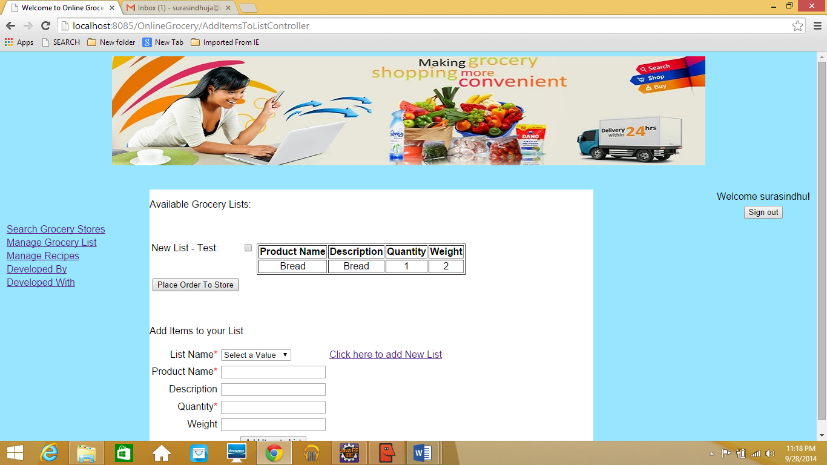

1. **Existing Design**

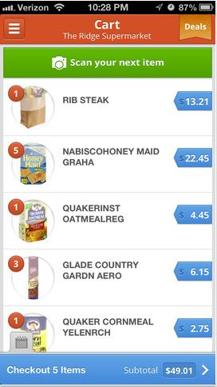

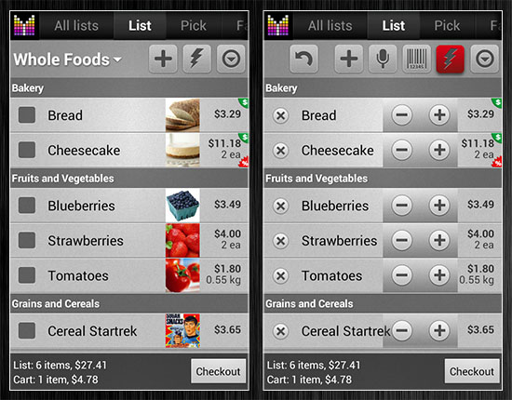

**3) Screenshots:**

**Homepage**

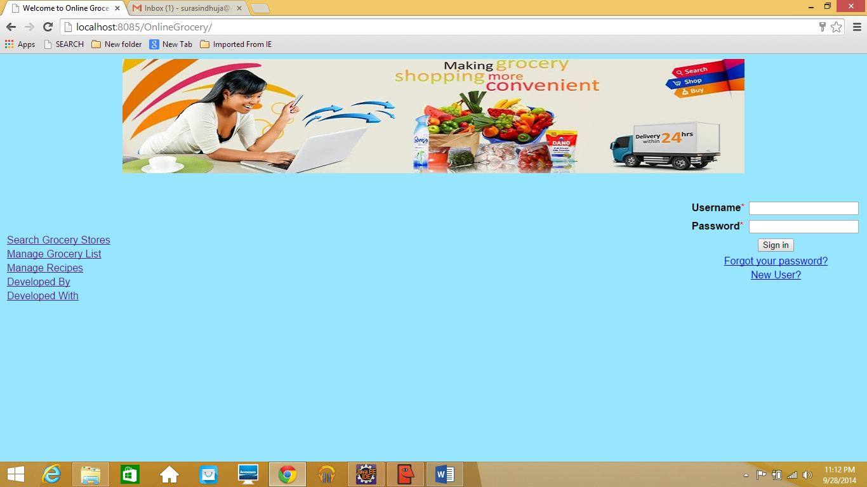

**LoginPage**

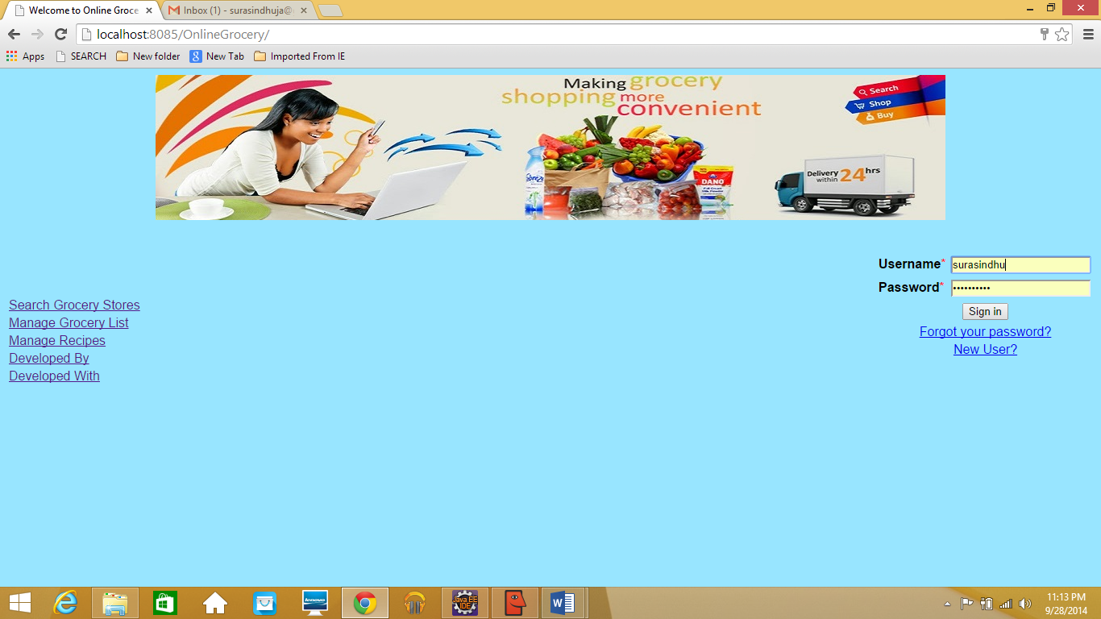

**Search Grocery Stores Page**

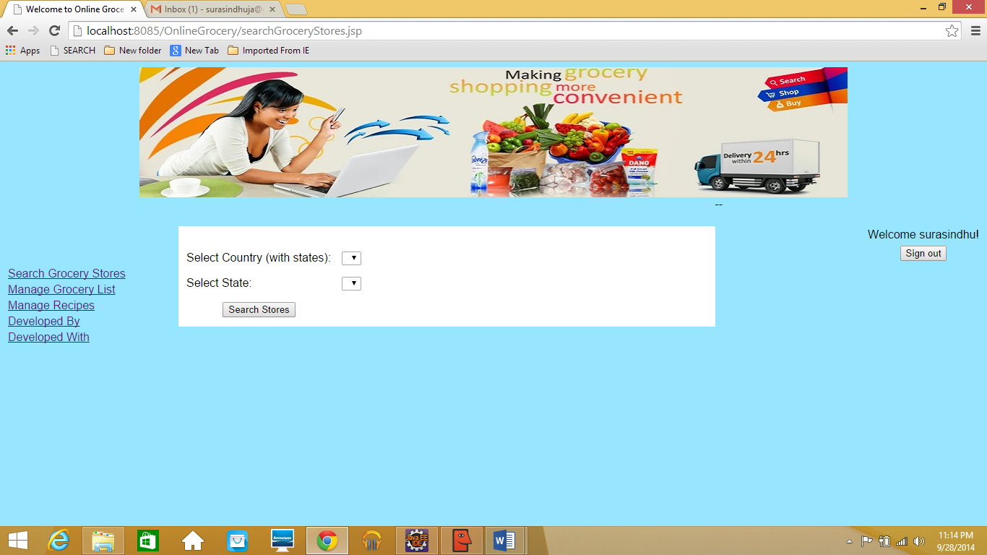

**Manage Grocery List Page**

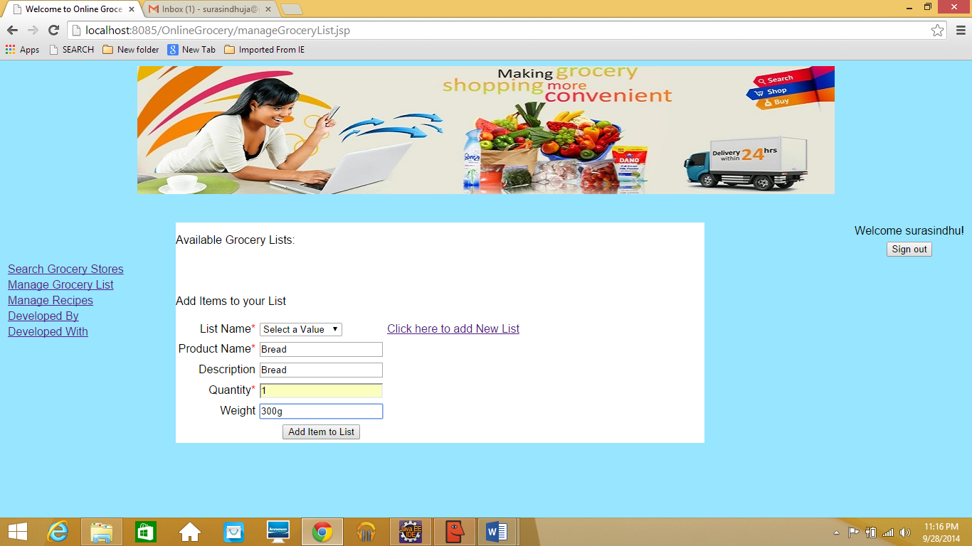

**Manage Recipes Page**

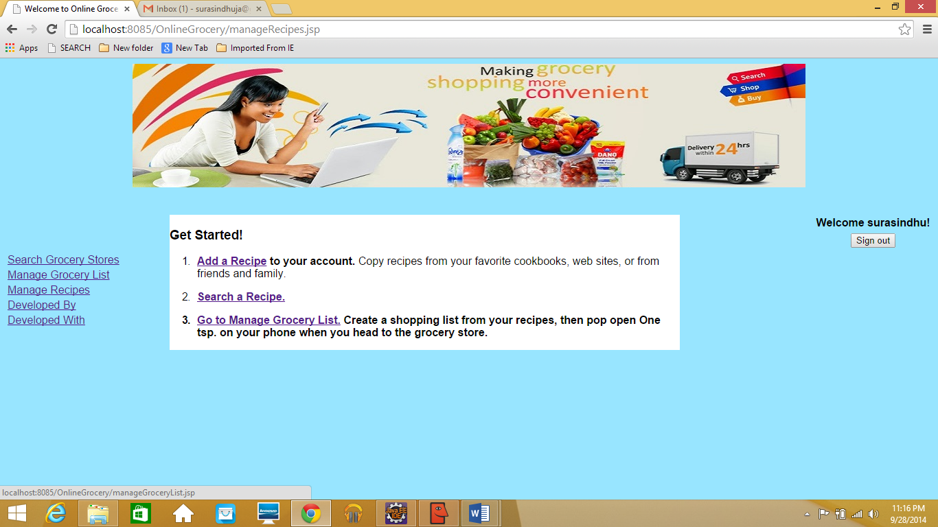

**Recipe Description Page**

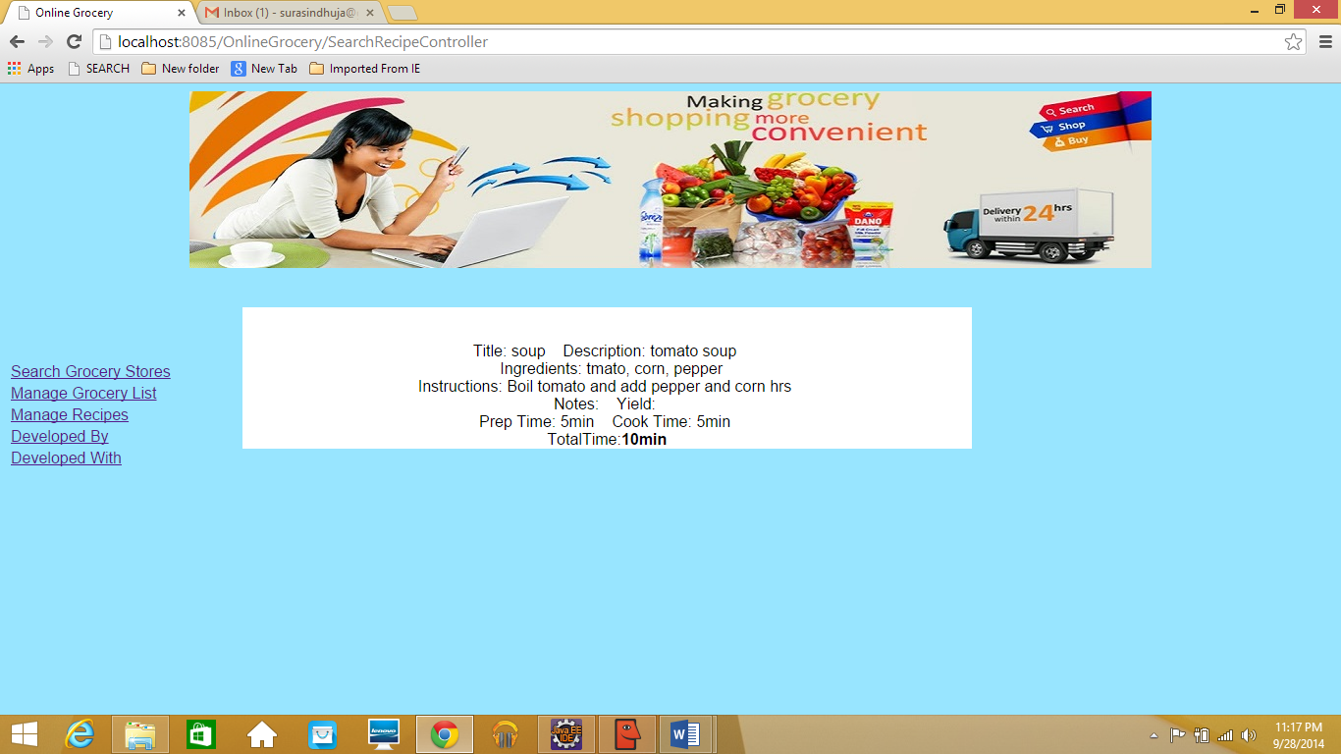

**Available Grocery List Page**



**Adding Item Page**

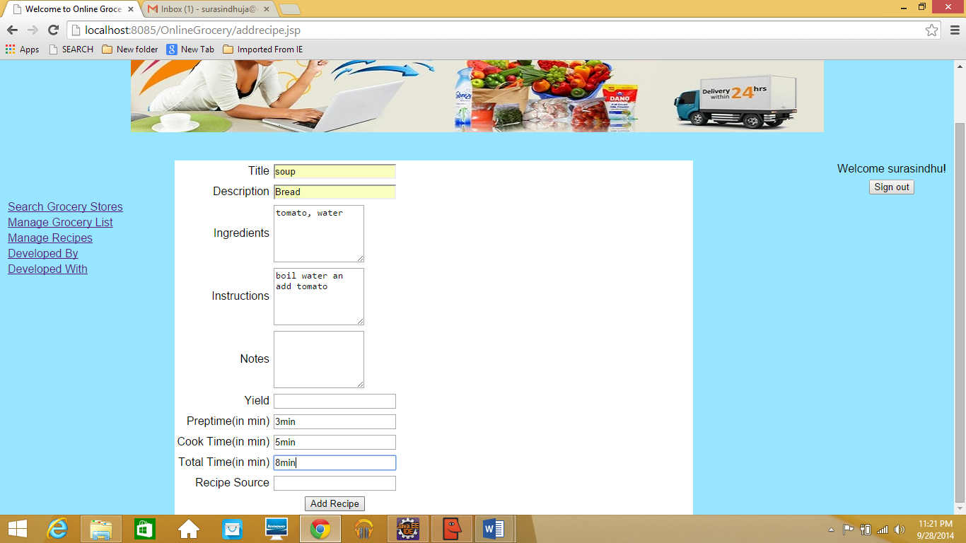

**Payment Page**

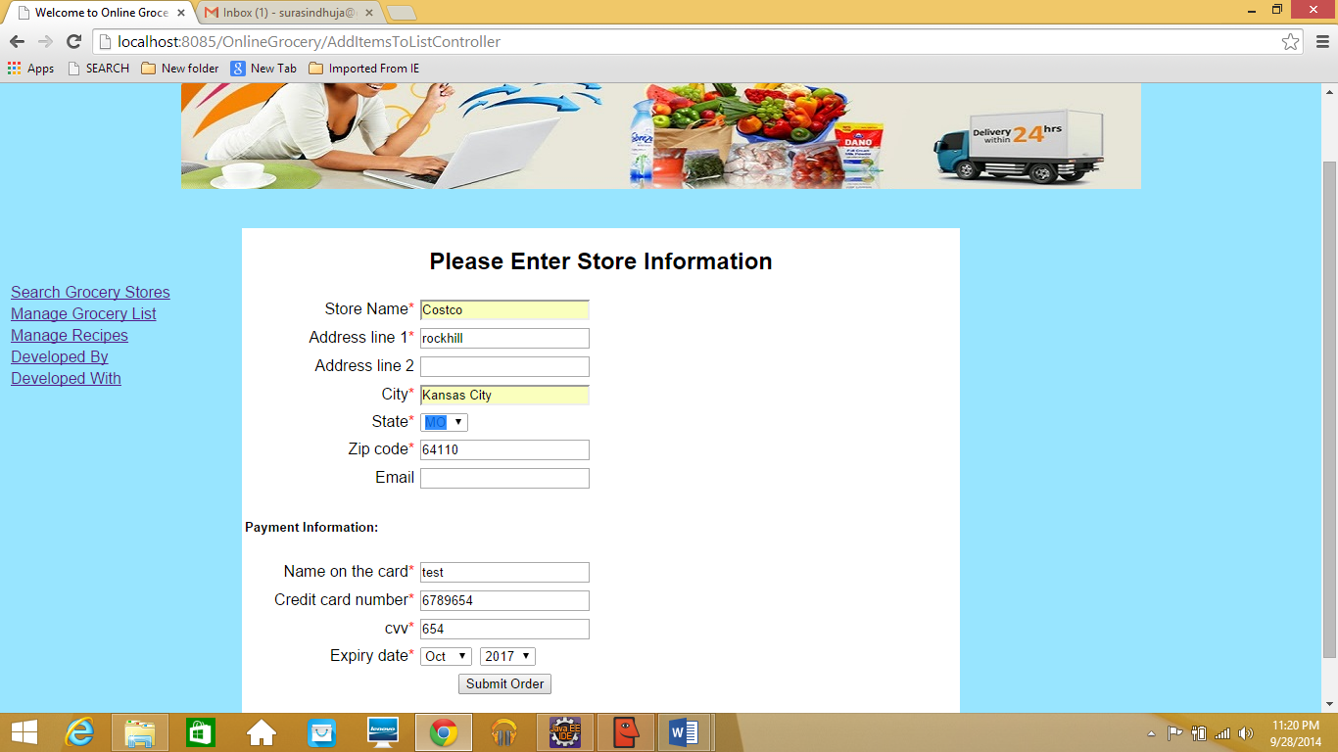

**4) Website URL:**

**http://localhost:8085/OnlineGrocery/**

**5) GitHub URL:**

[**https://github.com/sindhujasura/OnlineGrocery**](https://github.com/sindhujasura/OnlineGrocery)

**6) Limitations:**

* Mobile has a very small screen when compared to desktops and laptops, so it is a little problematic for the users to navigate from page to page and choose from a thousand options.
* Because of the technological changes day by day, mobile applications is one of the growing fields, but it has got security problems as it is a wireless network.
* Hacking chances are more during the data transfer.
* A mobile device can be used to its full potential only when interaction technologies are embedded.
* Most users hesitate to make transactions online because of security and privacy issues.

**7) References:**

<https://ibotta.com/>

<http://www.groceryiq.com/Login.aspx#>

<https://onetsp.com/manage/recipe>

<http://www.supermarketapi.com/>